SPH3U0 Kinematics Equations Practice Problems Date:__________

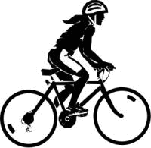1. A cyclist traveling at 14.0 m/s skids to a stop in a time of 5.60 s undergoing uniform acceleration.

Determine the skidding distance and the magnitude of the acceleration.

2. A runner, starting from rest, accelerates uniformly at 1.40 m/s2 for 8.00 s.

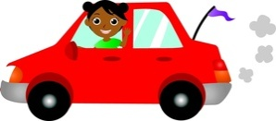 a) What is the runner’s final speed?

b) What is the runner’s average speed?

c) How far does the runner travel?

3. A car travelling at 14.0 m/s west accelerates at 2.30 m/s2 west for 2.70 s. What is its displacement

in that time? What is its final velocity in m/s? What is its final velocity in km/h?

4. If 100 m sprinters accelerate from rest for 3.50 s at 2.80 m/s2, how far have they run to this

point? What speed have they achieved at the end of the acceleration phase? How long will it take

them to complete the 100 m sprint if they maintain their speed the rest of the way?

5. a) If you accelerate (slow down) to a stop at –1.60 m/s2 by applying brakes, what is your *stopping*

*distance* (displacement from the time of applying the brakes) when your initial velocity is: i) 50.0 km/h forward ? ii) 100.0 km/h forward ?

b) What recommendation would you make regarding road speed limits based on your answer?

6. A roller coaster reaches a speed of 115 km/h in 7.00 s after starting at the top of the first hill

from rest . What is its average acceleration in m/s2? How far has it traveled in that time?

7. A car is slowing down with an acceleration of 5.60 m/s2 [West]. What is its displacement while

accelerating if its initial velocity was 50.0 km/h [East] and its final velocity is 5.00 m/s [East]?

8. A ball rolls up a hill with an initial velocity of 5.0 m/s [ up]. Four seconds (4.0 s) later, it is

moving down the hill with a velocity of 9.0 m/s [ down]. Find the displacement from its initial

release point.

9. A typical person can tolerate a maximum acceleration of magnitude 49.0 m/s2. Assume that a

passenger is initially travelling in a car moving at 110.0 km/h [forward] when the car has a collision

with a large, solid tree which does not move. Over what minimum distance must the person stop in

order to not exceed the value of the maximum acceleration? Explain how crumple zones and air

bags in cars can help achieve the desirable acceleration.

***Challenge Problem***

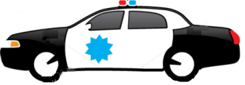10. A police car stopped at a set of lights is passed by a speeding car traveling at 100.0 km/h. If the

police car can accelerate at 3.60 m/s2, find

a) the time required for the police car to catch the speeding car

b) the distance from the lights at which the police car catches the speeding car

c) the final speed attained by the police car when it catches the speeding car. Is this

speed reasonable?

*Answers:*

*1. 39.2 m, 2.50 m/s2 6. 4.56 m/s2*

*2. a) 11.2 m/s b) 5.60 m/s c) 44.8 m 7. 15.0 m [East]*

*3. 46.2 m [W] 20.2 m/s [W] 72.8 km/h [W] 8. 8.0 m [ down the slope]*

*4. 17.2 m, 9.80 m/s, 8.45 s 9. 9.53 m*

*5. a) i. 60.3 m [F] ii. 2.41 x 102 m [F] 10. a) 15.4 s b) 4.29 x 102 m c) 55.6 m/s or 2.00 x 102 km/h*